**ASSIGNMENT-7.2**

**Course: AI Assisted coding**

**Name: B. Divya Sri**

**HT NO: 2403A51425**

**Batch- 16**

**#Task1:** 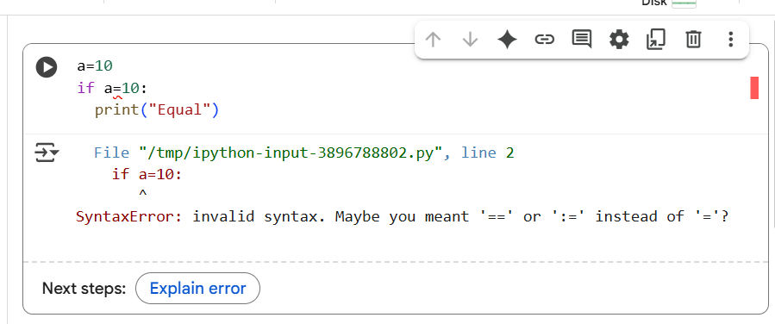

**Explanation of error:**

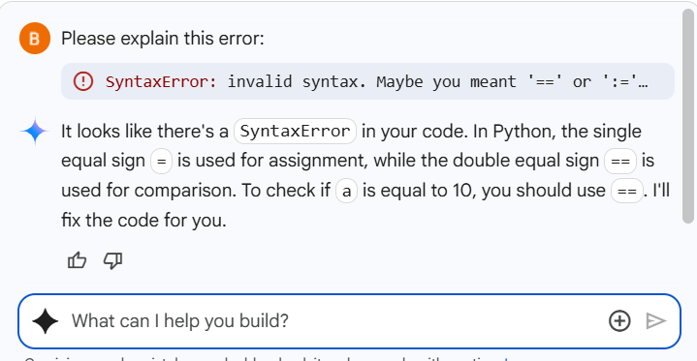

**Corrected code:**

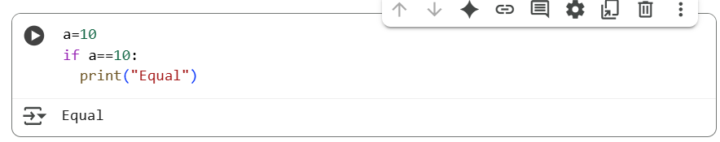

**#Task 2:**

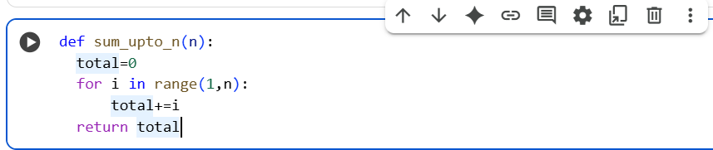

**Explanation of error:**

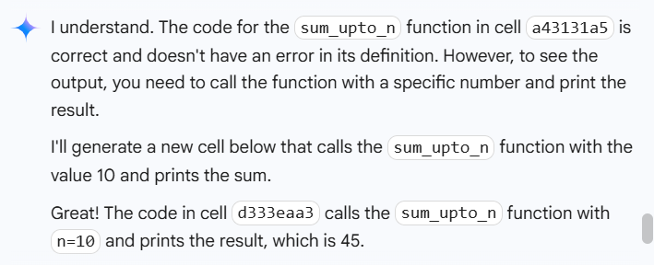

**Corrected code:**

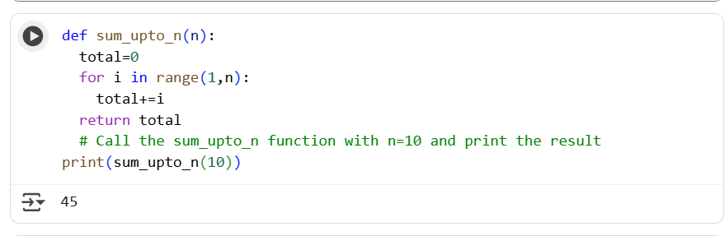

**#Task 3:**

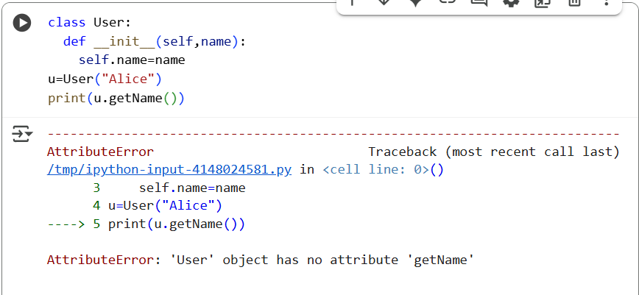

**Explanation of error:**

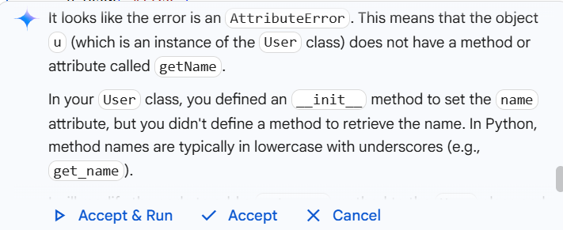

**Corrected code:**

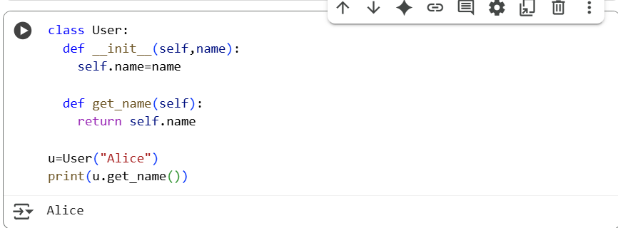

**#Task 4:**

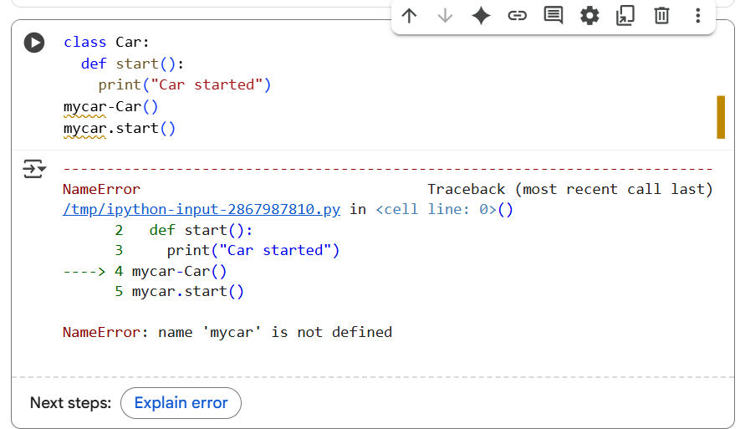

**Explanation of error:**

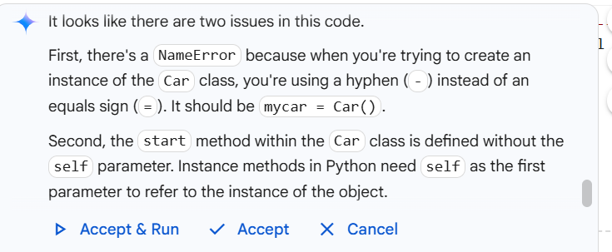

**Corrected code:**

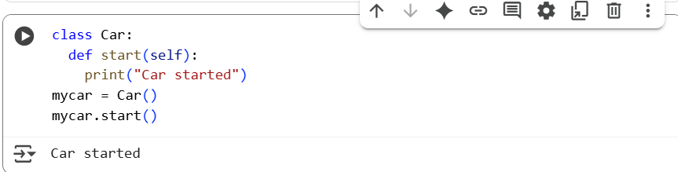

**#Task 5:**

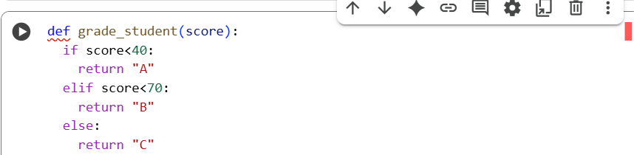

**Explanation of error:**

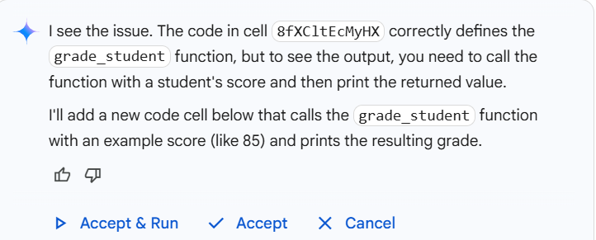

**Corrected code:**

